Use this guide for a quick overview of the most common features in the Academics app in Workday.

The Academic App is the hub for your academic information. From this location, you can create a saved schedule, register for courses, add, drop, or swap courses, review your academic progress (including GPA and credit hours), find your academic advisor contact information, and much more.
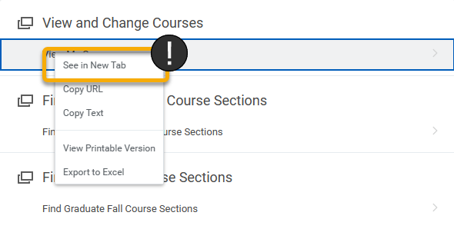

TIP: To move around Workday more easily, right click links and open in new tab. When finished with the tab, simply close and return to the previous window.

INSTRUCTIONS – How to Access the Academic App
- To access your Academic App, log into Workday and click Academics from the right-hand menu or the upper left menu.

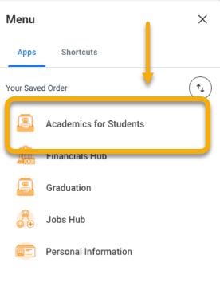

INSTRUCTIONS – How to Use the Academic App

There are five tabs in the Academic App. Each tab displays information or presents tasks related to your academics. Use this guide to get an overview of each tab.

Announcements and Forms Tab

Here, you can get help using Workday through how-to guides and videos. You can also change your preferred name. Your preferred name will display throughout your account, as well as in staff and faculty accounts.

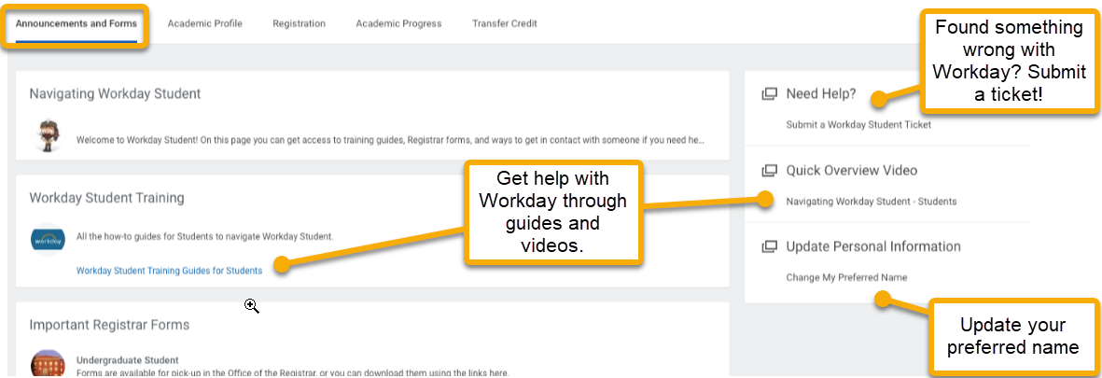

Academic Profile Tab

This tab displays a table with your current academic profile, including your programs of study, class standing, and expected date of graduation. If you think this information is incorrect, speak with your advisor.

TIP: Program of study refers to your major, minor, or emphasis.

The right-hand menu features access to your grades and academic record.

There are two links to view grades.

View My Grades will show your final grades, if they are available. View My Interim Grades will show your interim grades at any point during the academic period. Your interim grades change over the period, final grades will be…final.

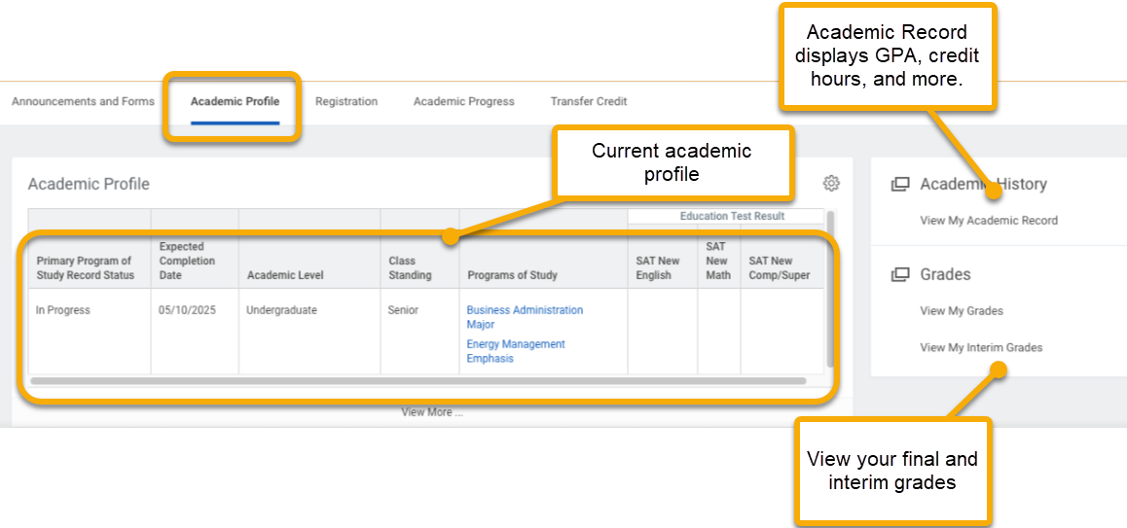

From the Academic Profile tab, you can also click View My Academic Record.

This useful tool gives you immediate access to your GPA, hours earned, course enrollment and more.

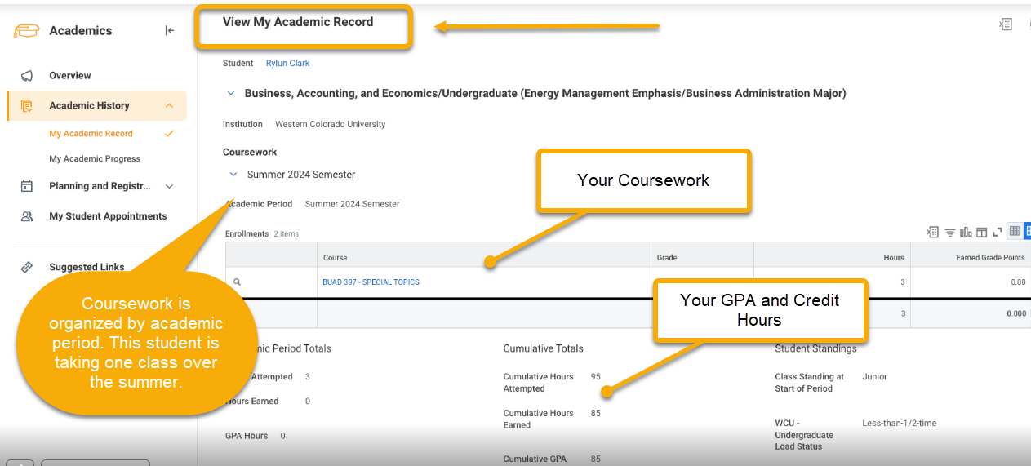

Registration Tab

This tab is the center for all the tools needed to register and manage your classes, including course research, creating saved schedules, requesting pre-requisite overrides, checking for course eligibility, and adding/dropping courses.

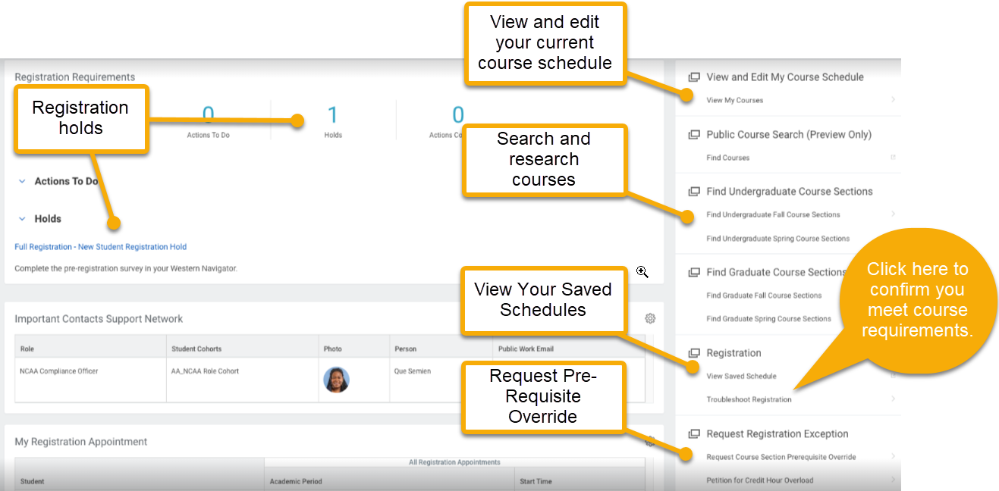

Academic Progress Tab

This tab takes you to your academic progress report. This report tells you which academic requirements you have completed AND which requirements you have NOT completed.

You will use your academic progress report to plan your course schedule.

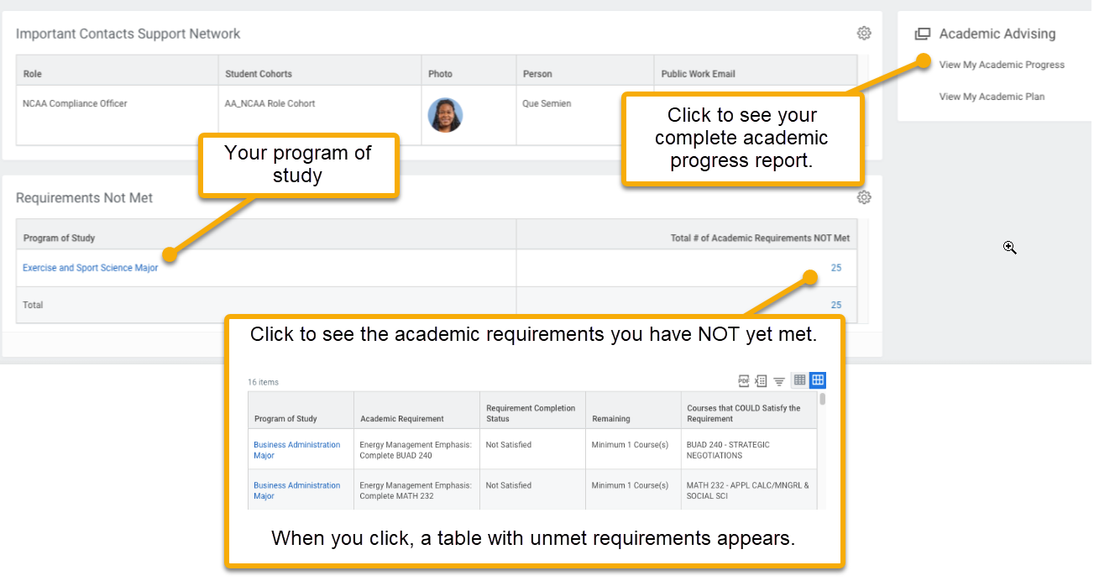

Click View My Academic Progress to see your complete academic progress.

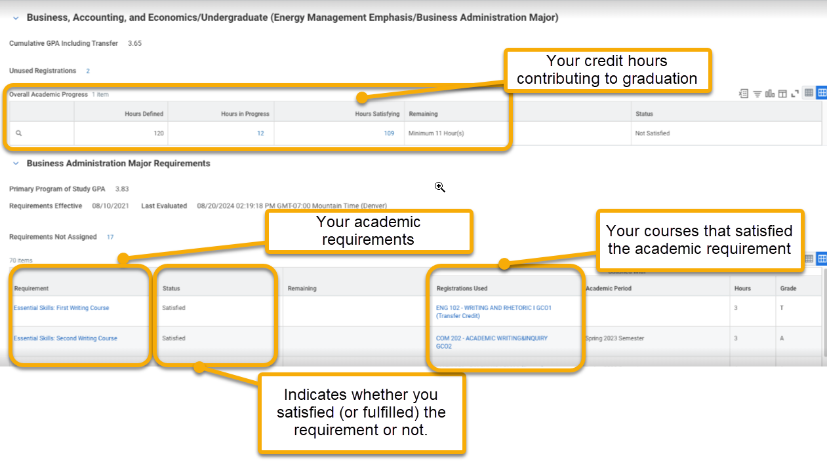

Transfer Credit Tab
This tab summarizes any transfer credits that have been accepted and applied to your academic record.
